**Linux Networking**

**IP classes:**

* Class A:
* The classful subnet mask is /8.
* The value starts from 1-126
* Class B:
* The classful subnet mask is /16.
* The value starts from 128-191.
* Class C:
* The classful subnet mask is /24.
* The value starts from 192-223

**Set the dynamic IP address:**

select VM ---> settings ---> Add Network adapter

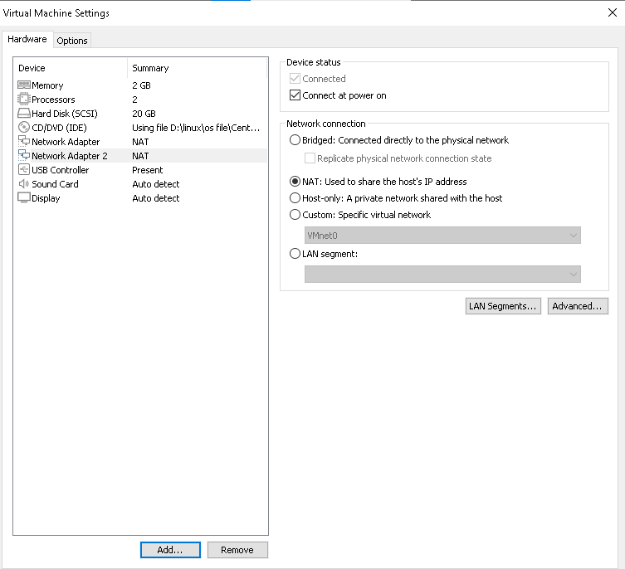

* ifconfig (check the IF name)

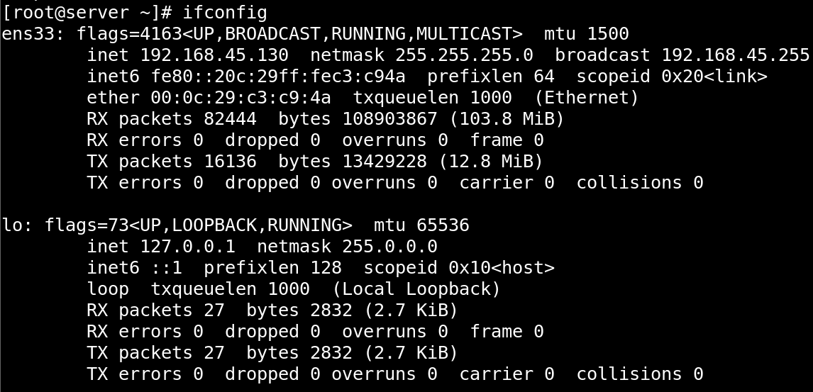

* nmcli device show

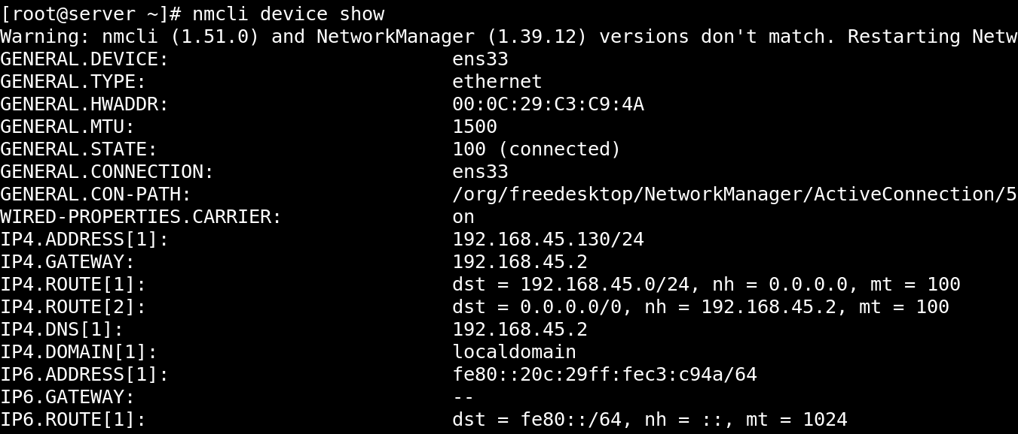

* nmcli device connect <network adapter name>ens36

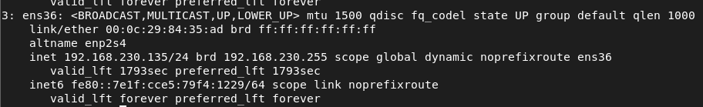

* nmcli connection

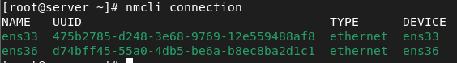

* nmcli con add type ethernet con-name ens14 ifname ens35 ipv4.addresses 192.168.159.51/24 ipv4.gateway 192.168.0.1 autoconnect yes ipv4.method manual

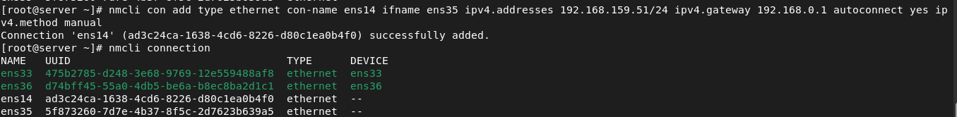

Command to check gateway:

* netstat -rn
* route -n

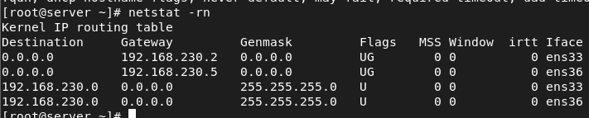

TO Modify Connection:

* nmcli con mod ens36 ipv4.addresses 192.168.2.100/24



To modify the ip to up the device:

* ifup



To check ip is changed or not:

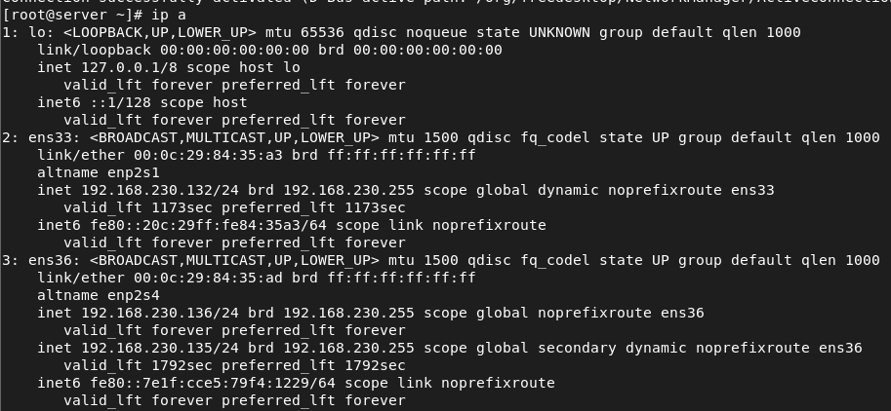

* nmcli con mod ens36 ipv4.gateway 192.168.2.1

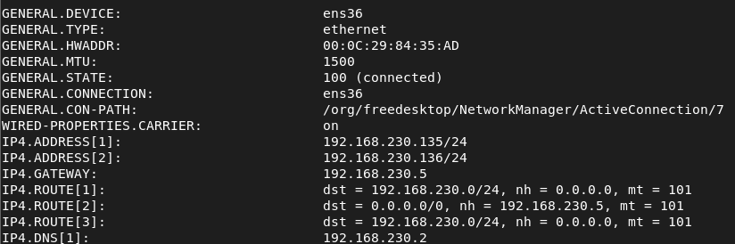

* nmcli con mod ens36 ipv4.dns 8.8.8.8

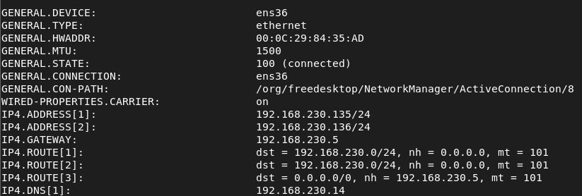

* nmcli con mod ens36 ipv4.method manual



* nmcli con mod ens36 connection.autoconnect yes



To change all details at same time:

* nmcli con modify ens160 ipv4.addresses 192.168.2.100/24 ipv4.gateway 192.168.2.1 ipv4.method manual connection.autoconnect yes

